Mechanical platform

The authors’ main goal from a mechanical perspective is to make room for all the electronic parts, including the Raspberry Pi, breadboard, camera, thermal sensors, motors, batteries, wiring, etc. To ensure that motors and sensors don't wobble while operating, the mechanical housing should also have specific design elements.

*1)Concept generation*

Our authors developed the design below during preliminary conversations, with the electronic components on the top and bottom base plates intended to be made of acrylic. The writers have also decided to use the trike's motorized front wheels and driven rear wheels for propulsion. For the robot's turning, the differential drive concept was selected.

*2) Design iterations*

*i) Initial design:* A CAD model that replicated the idea was created by designers. A table-like framework was all that was originally intended to house sensors at the top and other electrical components that would be packaged below the base.

*2) Final design:* A snake-head structure was created following multiple forums, as seen below. There is adequate room for sensors at the top that resemble the snake's eyes thanks to this snake-inspired design. Both housings' front sections are sufficiently shaped to avoid obstructing the sensor's field of vision.

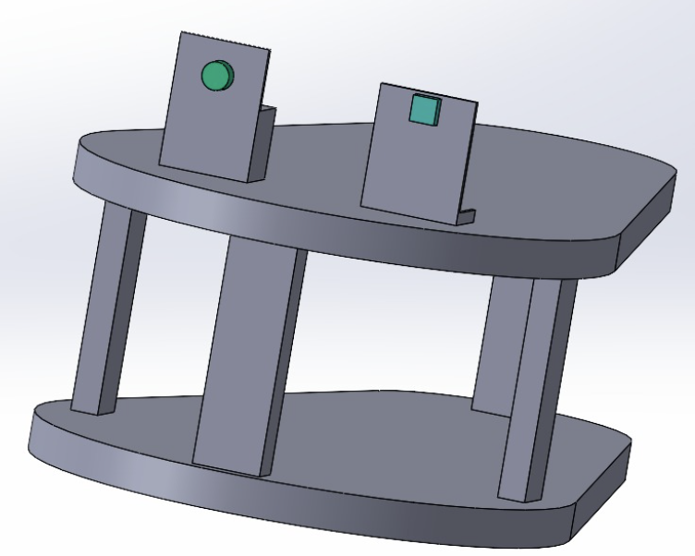

*Final design*

*Initial design*

Manufacturing failures

The body and wheels were created by the writers using 3D printing technology. The outputs were not what was anticipated because of the design's robustness. The body designs were divided into multiple pieces and intended to be joined using the projections and holes method, based on the lessons learned about designing quickly for manufacturing (3D printing). Following a difficult post-printing procedure that resulted in assembly features breaking, the bodies were assembled using Velcro and glue. Velcro is specifically employed to make assembly/disassembly feasible in the event that electronics need to be updated.

